Answer Center Christian Academy
Shipping Address:
5166 Old Norcross Road, Norcross, GA 30071

2019 – 2020
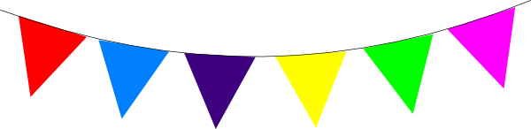
Required School Supply List

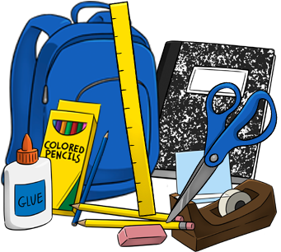
Student Supplies
- 12” non-flexible ruler
- Crayons and/or colored pencils (5th grade and up may bring markers)
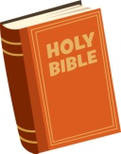
- Filler Paper (Wide or College Ruled)
- Headphones (for computer use)
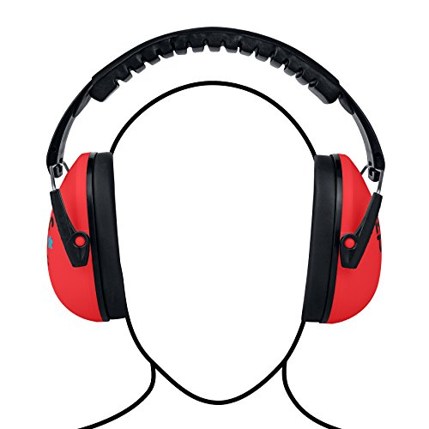
- Highlighters
- Large Erasers
- Magazine Holder (To hold PACES in office)
- Noise cancelling earmuffs
- Pencils (2 required at all times) (Mechanical pencils may be used for 4th grade and up)
- Personal Bible (King James Bible)
- Scissors
- Standard 1 to 2” notebook and 5-tab dividers (Dividers to be labeled: Math, English, Word Building, Science, and Social Studies)
- Supply box (for pencils, erasers, crayons, etc.)

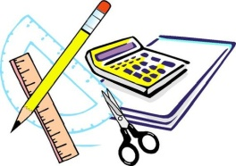
Math Supplies
- Calculator for 7th grade and up (Texas Instrument TI-30X IIs or better)
- Compass and Protractor (7th grade and up)
- Graph paper (for Math – 4th grade and up)

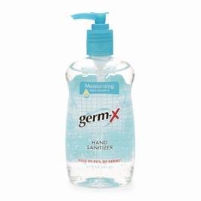
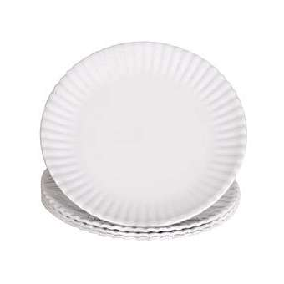
School Supplies
- 1 Ream (500 sheets) of printer/copier paper
- 1 pack of paper plates (microwave friendly)
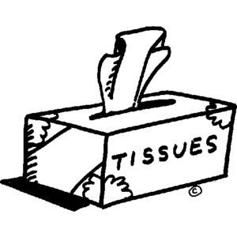
- 1 bottle of dawn dish soap
- 2 bottles of hand sanitizer (germX is the best)
- 2 packs of napkins
- 2 bottles of hand soap
- 3 boxes of Kleenex

If you would prefer, you are welcome to purchase any of these items on Amazon and have them shipped directly to the school.
Amazon Wish List name: Answer Center Christian Academy

